###### Sitecore – Add missing icons for specific media types – Vincent – Technologist

**SITECORE HACKATHON 2022**



**Topic**

**Best Addition to the Sitecore MVP site**

|  |  |
| --- | --- |
| **Team Name** | : SitecoreShade |
| **Team Members** | : Arul Pushpam Murugan, Chirag Goel |
| **Date** | : 05-March-2022 to 06-March-2022 |
|  |  |

**Introduction**

Sitecore is a leading digital experience software used by organizations globally to create seamless, personalized digital experiences. Sitecore is an integrated platform powered by .net CMS, commerce and digital marketing tools.

Sitecore JSS stands for Sitecore JavaScript Services, Sitecore JavaScript Services allow you to develop against the Sitecore Experience Platform in decoupled JavaScript applications.

Sitecore provides a suite of services, APIs, and software development kits (SDKs) that allow you to develop decoupled applications using Sitecore data, transforming Sitecore into a headless content management system (CMS). **Sitecore JSS supports developing using react js, angular js, vue js and next js applications with Sitecore.**

Sitecore have recently launched a new way to create websites using ASP.NET Core rendering as a headless method. NET Core is Microsoft's answer to the new coding standards and the way people build things now online. It is micro services oriented.

**Working with Sitecore MVP site**

Sitecore MVP site is an open source website. We can work on the MVP site in Docker Container mode or we can configure it on our local instance.

We have configured the Sitecore MVP site in our local instance instead of Docker to achieve more productive results.

**What we have enhanced in MVP site**

We have added a MVP Reviewers page which provides the details of people who have reviewed your MVP applications.

We also added the LinkedIn and Twitter links for the people who are the Sitecore MVP in the MVP Directory.

**You can see the results at last.**

**Steps to Install in your Sitecore Instance**

1. Firstly you have to take our GitHub branch in your local.
2. Create Rendering Host Website with SSL certificate in your IIS.

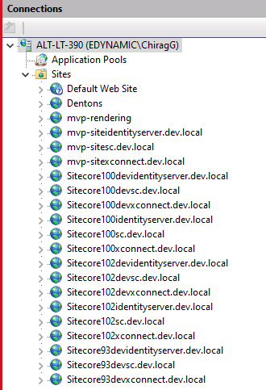

1. Then you have to update the appsettings.json file at the path MVP-Site\src\Project\MvpSite\rendering\appsettings.json.

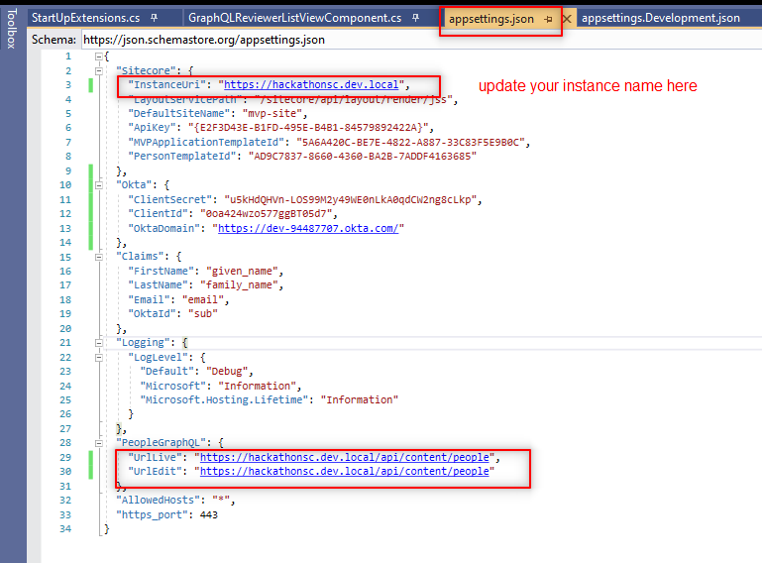

1. Then you have to update the app appsettings.Development.json file at the path MVP-Site\src\Project\MvpSite\rendering\appsettings.Development.json.

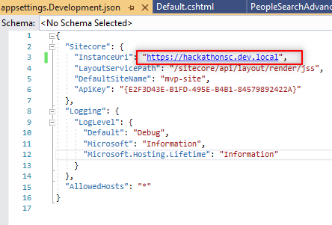

1. You also need to update the Directory.Build.targets file located at the path Mvp-Site\Directory.Build.targets.

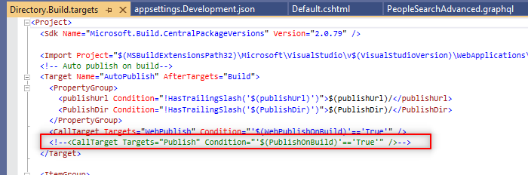

1. You also need to update the hostname in MVP-Site\src\Project\MvpSite\platform\App_Config\Include\Project\Project.MvpSite.config file.

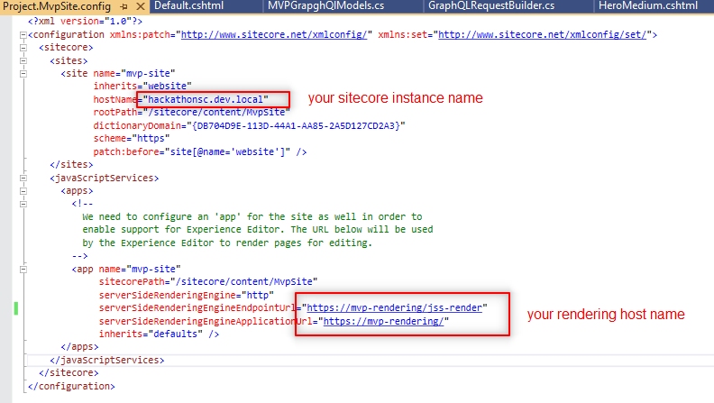

1. Publish all the files to the rendering host we have created in the Step 2 for the project **Mvp.Project.MvpSite.Rendering** located at the path MVP-Site\src\Project\MvpSite\rendering\Mvp.Project.MvpSite.Rendering.csproj.
2. Now we have to move the dlls and config files from MVP-Site\docker\deploy\platform to our Sitecore Instance bin folder.

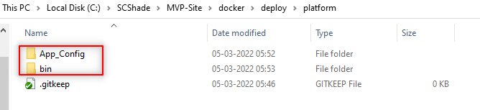

1. Now you have to perform the Content Serialization and publish the site from Sitecore.
2. Now you have you site running at your rendering host.

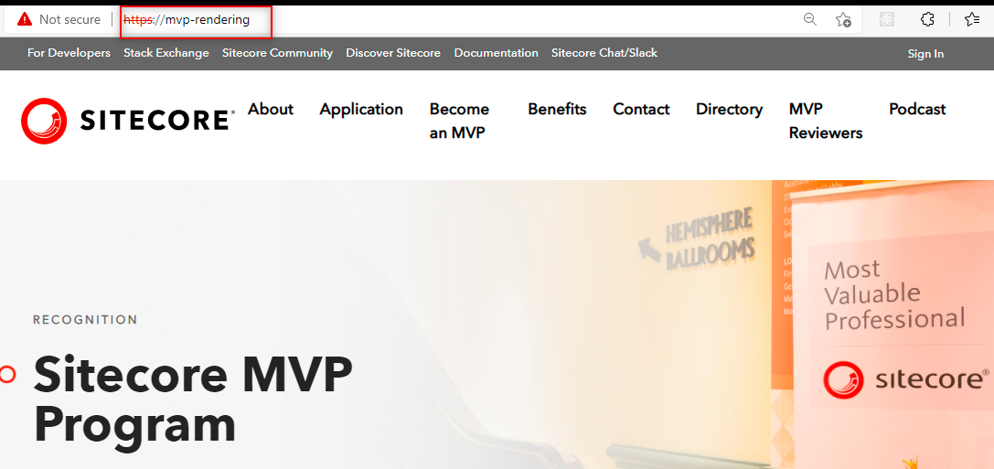

**Resultant output**

Here are some of the sample screenshots of the enhancement we have performed in Sitecore MVP website:

